Online K-means, ART and SOM

Description

In this implementation, I would be implementing online K-means and would augment it with adaptive resonance theory and self organizing maps.

Solution

In online k-means we keep on updating the centres with every coming point. In online k-means we only update the centres to which the incoming point belongs to.

In adaptive resonance theory we start with only one centre and keep on adding new centres if the incoming point do not fall under the vigilance boundary of any of the existing centre. We use the domain knowledge to define the vigilance boundary.

In self-organizing maps we not only update the centre closest to the upcoming point. We update the neighboring centres as well. We define a neighbouring function and update all the neighbouring points based on that function.

Results

We tried all the algorithms and calculated the reconstruction error to evaluate the performance of the algorithms. We are taking a step size of 0.01 for all three algorithms.

Implementing Online K-means: -

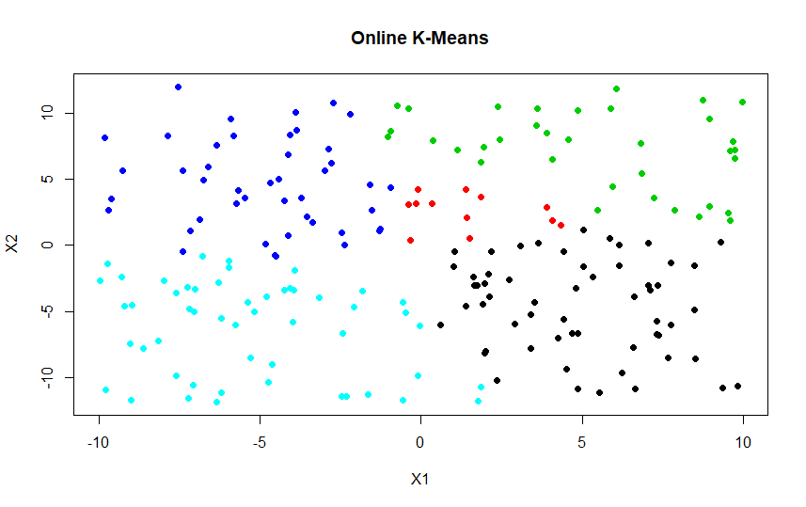

The figure above shows the implementation of online k-means with 5 classes and a dataset with 200 points.

We are calculating the reconstruction error to measure the performance of online k means algorithm.

The reconstruction error we get for this case is 19522.86.

Implementing adaptive resonance theory: -

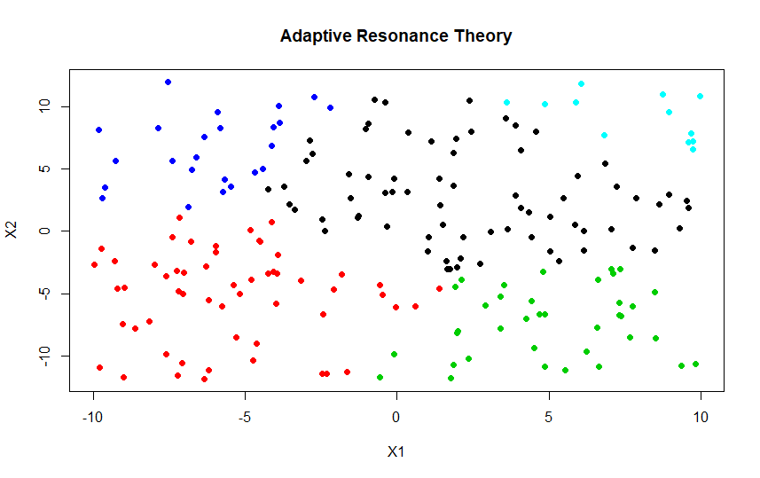

In this case we are implementing adaptive resonance theory with a vigilance of 10 and are getting 5 classes in this case. In this case we are getting a reconstruction error of 19687.62.

Implementing self-organizing maps: -

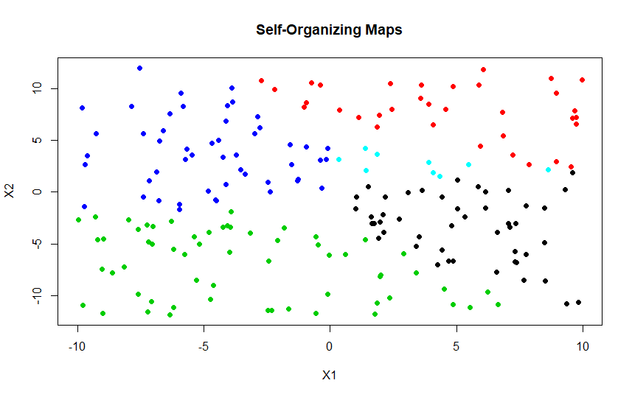

We are implementing self organizing maps where we take 2 neighbors base on their proximity (Euclidean distance) and update them as well.

We are getting a reconstruction error of 19604.2 with this algorithm.